I don’t think this video gives you a very good impression of Mr. Trump. The clip is to short and you can’t see what has happened before that question. Maybe the other interview questions have been very nasty and therefore he was already tired of such questions. Still he didn’t respond very good and the question of the interviewer was not so nasty at all. But the interviewer did not have to play the racist card, it looks a bit unprofessional to do that as an interviewer.

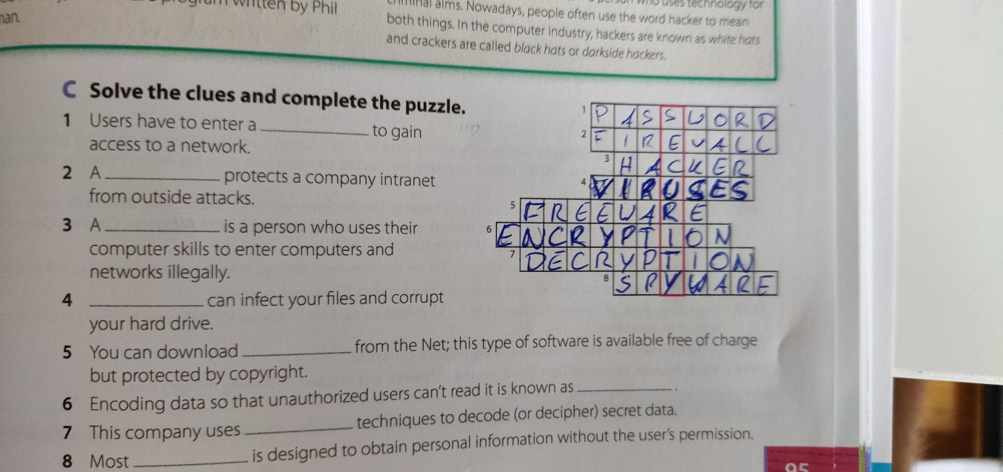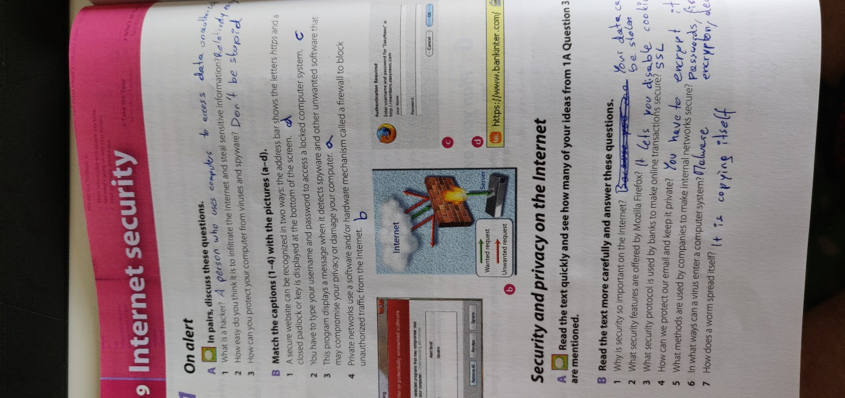Nonetheless I think that Mr. Trump is not handling the Corona Crisis very well but it’s not only his fault, it’s the fault of the whole government.

